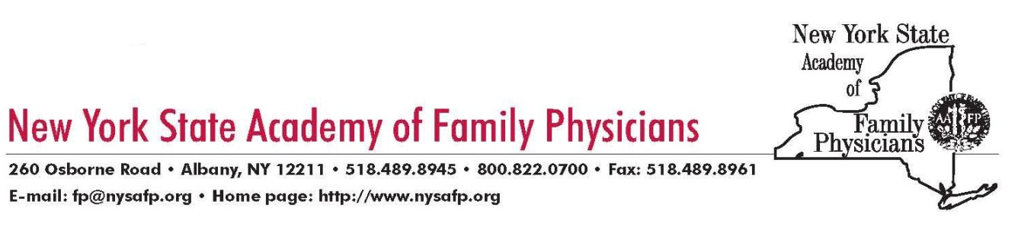

November 27, 2016

Honorable Joseph Pitts
Chair, Subcommittee on Health
Energy and Commerce Committee
114th United States Congress

Dear Congressman Pitts,

The New York State Academy of Family Physicians represents over 5,500 New York physicians, residents and students in family medicine. As president of the Academy, I offer support of the work of the US Preventive Services Task Force (USPSTF) as it has historically been constructed. I have spent my thirty year career practicing Family Medicine in rural upstate New York, as well as teaching medical students.

The USPSTF is an invaluable resource as an independent body of experts in primary care and evidence based preventive medicine that makes recommendations on clinical preventive services to improve the health of all Americans. We family physicians, including myself, rely on it more and more each year as we transform our focus from treating disease to promoting wellness and prevention. Their work is regarded as impartial and is committed to utilizing the best science available.

In following the recommendations of the National Academy of Medicine’s report “Clinical Practice Guidelines We Can Trust,” the USPSTF’s recommendations incorporate rigorous scientific review with expert subspecialty consultation and public comment in a clear and transparent process which has worked and has earned the respect and confidence of primary care physicians. Appropriate guideline recommendations about tests and treatments to prevent morbidity and mortality must be made taking into account all the effects of a particular intervention on the whole person. It is crucial that this process be directed by experts in outcomes based evidence from primary care specialties, who can look not only at the benefits of a test or treatment, but also at potential unintended harms and benefits relating to the disease process under consideration, and also affecting the entire individual, physically and psychologically.

The USPSTF’s recommendations are an essential part of providing comprehensive primary care to our patients and communities. They are a key element in our quest to pursue high quality and safe care for our individual patients, our families, our communities and the population as a whole. Their work should continue in the same unbiased, transparent manner as it does currently.

Sincerely,

Robert J. Ostrander, MD, President
NYS Academy of Family Physicians

