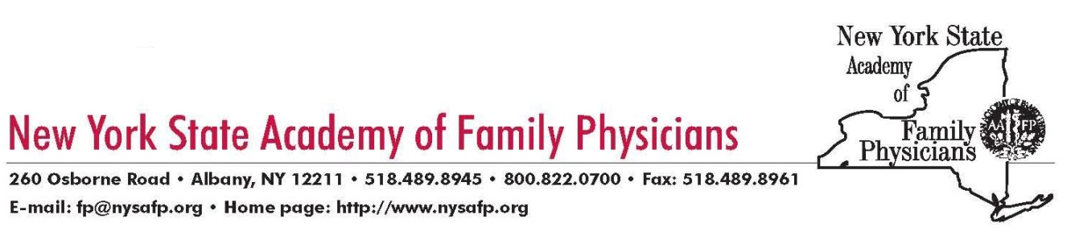
FOR IMMEDIATE RELEASE
Contact: Vito F. Grasso, MPA
Executive Vice President
(518)489-8945

Robert Ostrander, MD Elected President of Statewide Medical Society

Albany: The New York State Academy of Family Physicians (NYSAFP) has elected Robert Ostrander, MD, of Rushville to a one-year term as president of the Academy. Dr. Ostrander was elected at the NYSAFP Congress of Delegates on June 18th at the Hilton Garden Inn in Troy, NY.

Dr. Ostrander is a graduate of the Union College. He began his medical education at Albany Medical College before transferring to and graduating from Upstate Medical Center in Syracuse. He completed a residency in family medicine at St. Joseph’s Hospital in Syracuse, New York.

Dr. Ostrander has been in private practice since 1986. He was a co-founder of Valley View Family Practice Associates in 1997. Valley View is a three-physician practice with two offices and a satellite site and provides a full scope Family Practice care, including routine Obstetrics, office surgery, hospital care for adults and children and surgical assisting for major surgery for a rural community.

He is Clinical Associate Professor, Department of Family Medicine at SUNY Health Science Center in Syracuse; Primary Preceptor, in the Rural MED Program of the Department of Family Medicine at SUNY Upstate Medical University in Syracuse; and is a Family Practice Clerkship Preceptor for medical students and physician assistant students at the University of Rochester Medical School, University of Buffalo Medical School and Albany Medical College.

Dr. Ostrander is a member of the American Academy of Family Physicians, the New York State Academy of Family Physicians, the American Medical Association, the Medical Society of the State of NY, the Ontario County Medical Society and the Canandaigua Medical Society. He is a Diplomate of the American Board of Family Physicians and is a Fellow of the American Academy of Family Physicians.

He has made numerous presentations at medical conferences and was the 2003 recipient of the New York State Academy of Family Physicians’ Family Physician of the Year Award.

The NYSAFP is the New York chapter of the American Academy of Family Physicians. NYSAFP represents more than 5,500 family physicians and medical students throughout the state and provides advocacy, education and information for its members.

-30-

