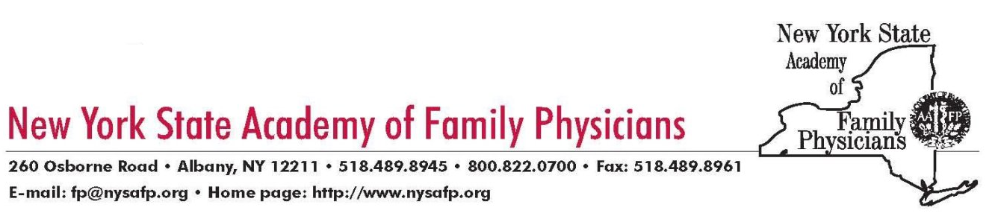

September 28, 2016

The Honorable Bill de Blasio

Mayor

City of New York

City Hall

New York, NY 10007

The Honorable Melissa Mark-Viverito

Speaker

New York City Council  
105 East 116th Street  
New York, NY 10029

***Re: Support for Funding to Study Supervised Injection Facilities***

Dear Mayor de Blasio and Speaker Mark-Viverito:

The New York State Academy of Family Physicians which represents over 5,500 physicians, residents and students in family medicine is writing to express our support for your efforts to allocate funding for the City Health Department to study supervised injection facilities, as announced recently.

At our annual Congress of Delegates this past June, our Academy resolved to support and

promote a pilot of safe injection facilities in New York. We understand that it is a

complicated and controversial issue but we also believe that such facilities will save

lives and help turn the tide on the serious heroin epidemic plaguing our State and nation.

According to the Centers for Disease Control and Prevention, heroin-related deaths jumped 39 percent from 2012 to 2013, and the longer-term trends are equally disturbing: from 2002to 2013, the rate of heroin-related overdose deaths nearly quadrupled. Recently, we saw City Health Department data which found that heroin and fentanyl related deaths increased by 17 percent in New York City last year alone.

The City and State have implemented a number of evidence-based harm reduction

strategies already such as making naloxone easily accessible for opioid overdose

prevention, clean needle and syringe exchange programs, and medication-assisted treatment programs (e.g. methadone and buprenorphine). While we are very supportive of these efforts, the growing trend in opioid related deaths indicates a need for continued and bold new efforts to stem the harms from opioid dependence.

De Blasio/Mark-Viverito - 2

A medically supervised safer injection facility is a harm reduction strategy that permits people who inject drugs to access sterile injecting equipment, receive education by health care personnel on methods of injecting that minimize the risk of abscesses or bloodstream infections, inject pre-obtained illicit drugs in an environment of supervision so to facilitate rapid assessment and treatment in cases of overdose, and easily access addictions counseling and treatment programs.

Such facilities exist in 98 sites in 66 cities in the world, including two well-studied sites in Vancouver, British Columbia and Sydney, Australia. Safer injection facilities have been shown to reduce sharing of used syringes,1 reduce public injection drug use, reduce publicly discarded syringes, reduce reuse of syringes, increase use of sterile water, increase use of alcohol swabbing at injection sites,2 increase referral to and uptake of addiction treatment services, especially for the most marginalized populations,3,4 with no increase in drug injecting rates, drug trafficking, or crime in surrounding areas.5

Further, evidence strongly suggests that medically supervised safer injection facilities reduce the rate of overdose deaths as well as reduce the number of opioid overdoses requiring ambulance or emergency department care.6 We believe access to such facilities is particularly important for homeless individuals who inject drugs and do so frequently in public spaces, such as parks, recreational areas or streets, and in public or commercial bathrooms. As part of the Health Department’s study of such facilities, we would respectfully urge that a pilot program be established in New York City, and perhaps with a focus on homeless individuals.

Thank you, for your consideration of our comments on this important topic. The Academy and our members throughout New York City and State stand ready to assist you with this and other related efforts to address the serious and deadly heroin epidemic that we are facing and must work together to solve.

Sincerely,



Robert J. Ostrander, MD

President

**________________________________________________________________________**

1. Kerr T, Tyndall M, Li K, Montaner J, Wood E. Safer injection facility use and syringe sharing in injection drug users. Lancet 2005;366 (9482):316–8.
2. Stoltz JA, Wood E, Small W, et al. Changes in injecting practices associated with the use of a medically supervised safer injection facility. J Public Health 2007;29 (1):35–9.
3. Wood E, Tyndall MW, Montaner JS, Kerr T. Summary of findings from the evaluation of a pilot medically supervised safer injecting facility. CMAJ 2006;175 (11):1399–404.
4. Vancouver’s INSITE service and other supervised injection sites: What has been learned from research? [Internet]. Health Canada. 2008 [cited 2/2016] ; Available from: http://www.hcsc.gc.ca/ahcasc/pubs/_siteslieux/insite/indexeng.php#insite
5. Potier C, Laprévote V, DuboisArber F, Cottencin O, Rolland B. Supervised injection services: what has been demonstrated? A systematic literature review. Drug Alcohol Depend 2014;145:48–68.
6. Salmon AM, van Beek I, Amin J, Kaldor J, Maher L. The impact of a supervised injecting facility on ambulance callouts in Sydney, Australia. Addiction 2010;105 (4):676–83.