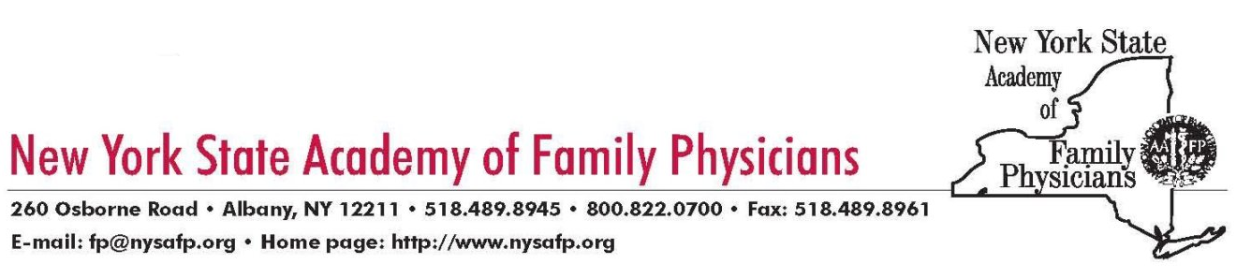

Jason Helgerson

Deputy Commissioner

Office of Health Insurance Programs

NYS Medicaid Director

One Commerce Plaza

Albany, NY 12210

November 22, 2016

Dear Mr. Helgerson:

The New York State Academy of Family Physicians, which represents over 5,500 physicians, residents and students in family medicine across the state, is writing to express our serious concerns with a Medicaid Managed Care issue that is impacting access to obstetrical services in Steuben County.

As you are likely aware, Fidelis Care is the only Medicaid Managed Care plan in Steuben County. Further, there is a lack of participating providers in Fidelis’ network, especially for obstetrical care. As a result, patients must travel to neighboring counties, like Ontario for deliveries including C sections. In these instances, family physicians are called in, taking them away from their practices for hours, which creates a resource and financial burden for small, private, primary care practices.

Yet Fidelis is refusing to pay such physicians for the OB care being provided in these cases, since they are non-par. When we asked our members why they do not participate with Fidelis they shared that rates are abysmally low and are not fair or adequate to cover costs. As compared to other plans, Fidelis is well below market rates.

This situation is placing physicians in an untenable situation. If patients in Steuben have no choice but to go to physicians who are outside their networks to deliver their babies, Fidelis should be required to cover such services. Physicians do not and will not turn their backs on these patients, but they deserve to be compensated, both for the care they provide and to offset their losses when they take time away from their own practices to serve these women.

We are writing to request that the State Department of Health examine the adequacy of the Fidelis Medicaid Managed Care plan network in Steuben and nearby counties. In particular for obstetrical services, since women who are in labor would not choose to travel a distrance3 to another county for services unless absolutely necessary, yet our members report this happening with multiple patients.

Page 2

We believe the Department must intervene and require Fidelis to pay non-par physicians for the services they provide in these instances where there are no other options. This is critical in the name of fairness to the physicians providing the care, and most importantly to ensure that women’s access to obstetrical services is not placed in jeopardy.

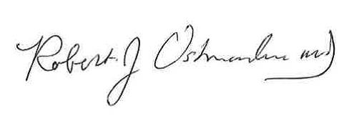We thank you for your consideration of our concerns and ask that you take swift action to address this serious situation.

Sincerely,

Robert Ostrander, MD  
President

Cc: Jonathan Bick

Senator Thomas O’Mara

Assembly Member Joseph Giglio

Assembly Member Philip Palmesano